**Design a power adaptor circuit with 230V AC input and 5V DC, 2A Output**

**Circuit diagram:**

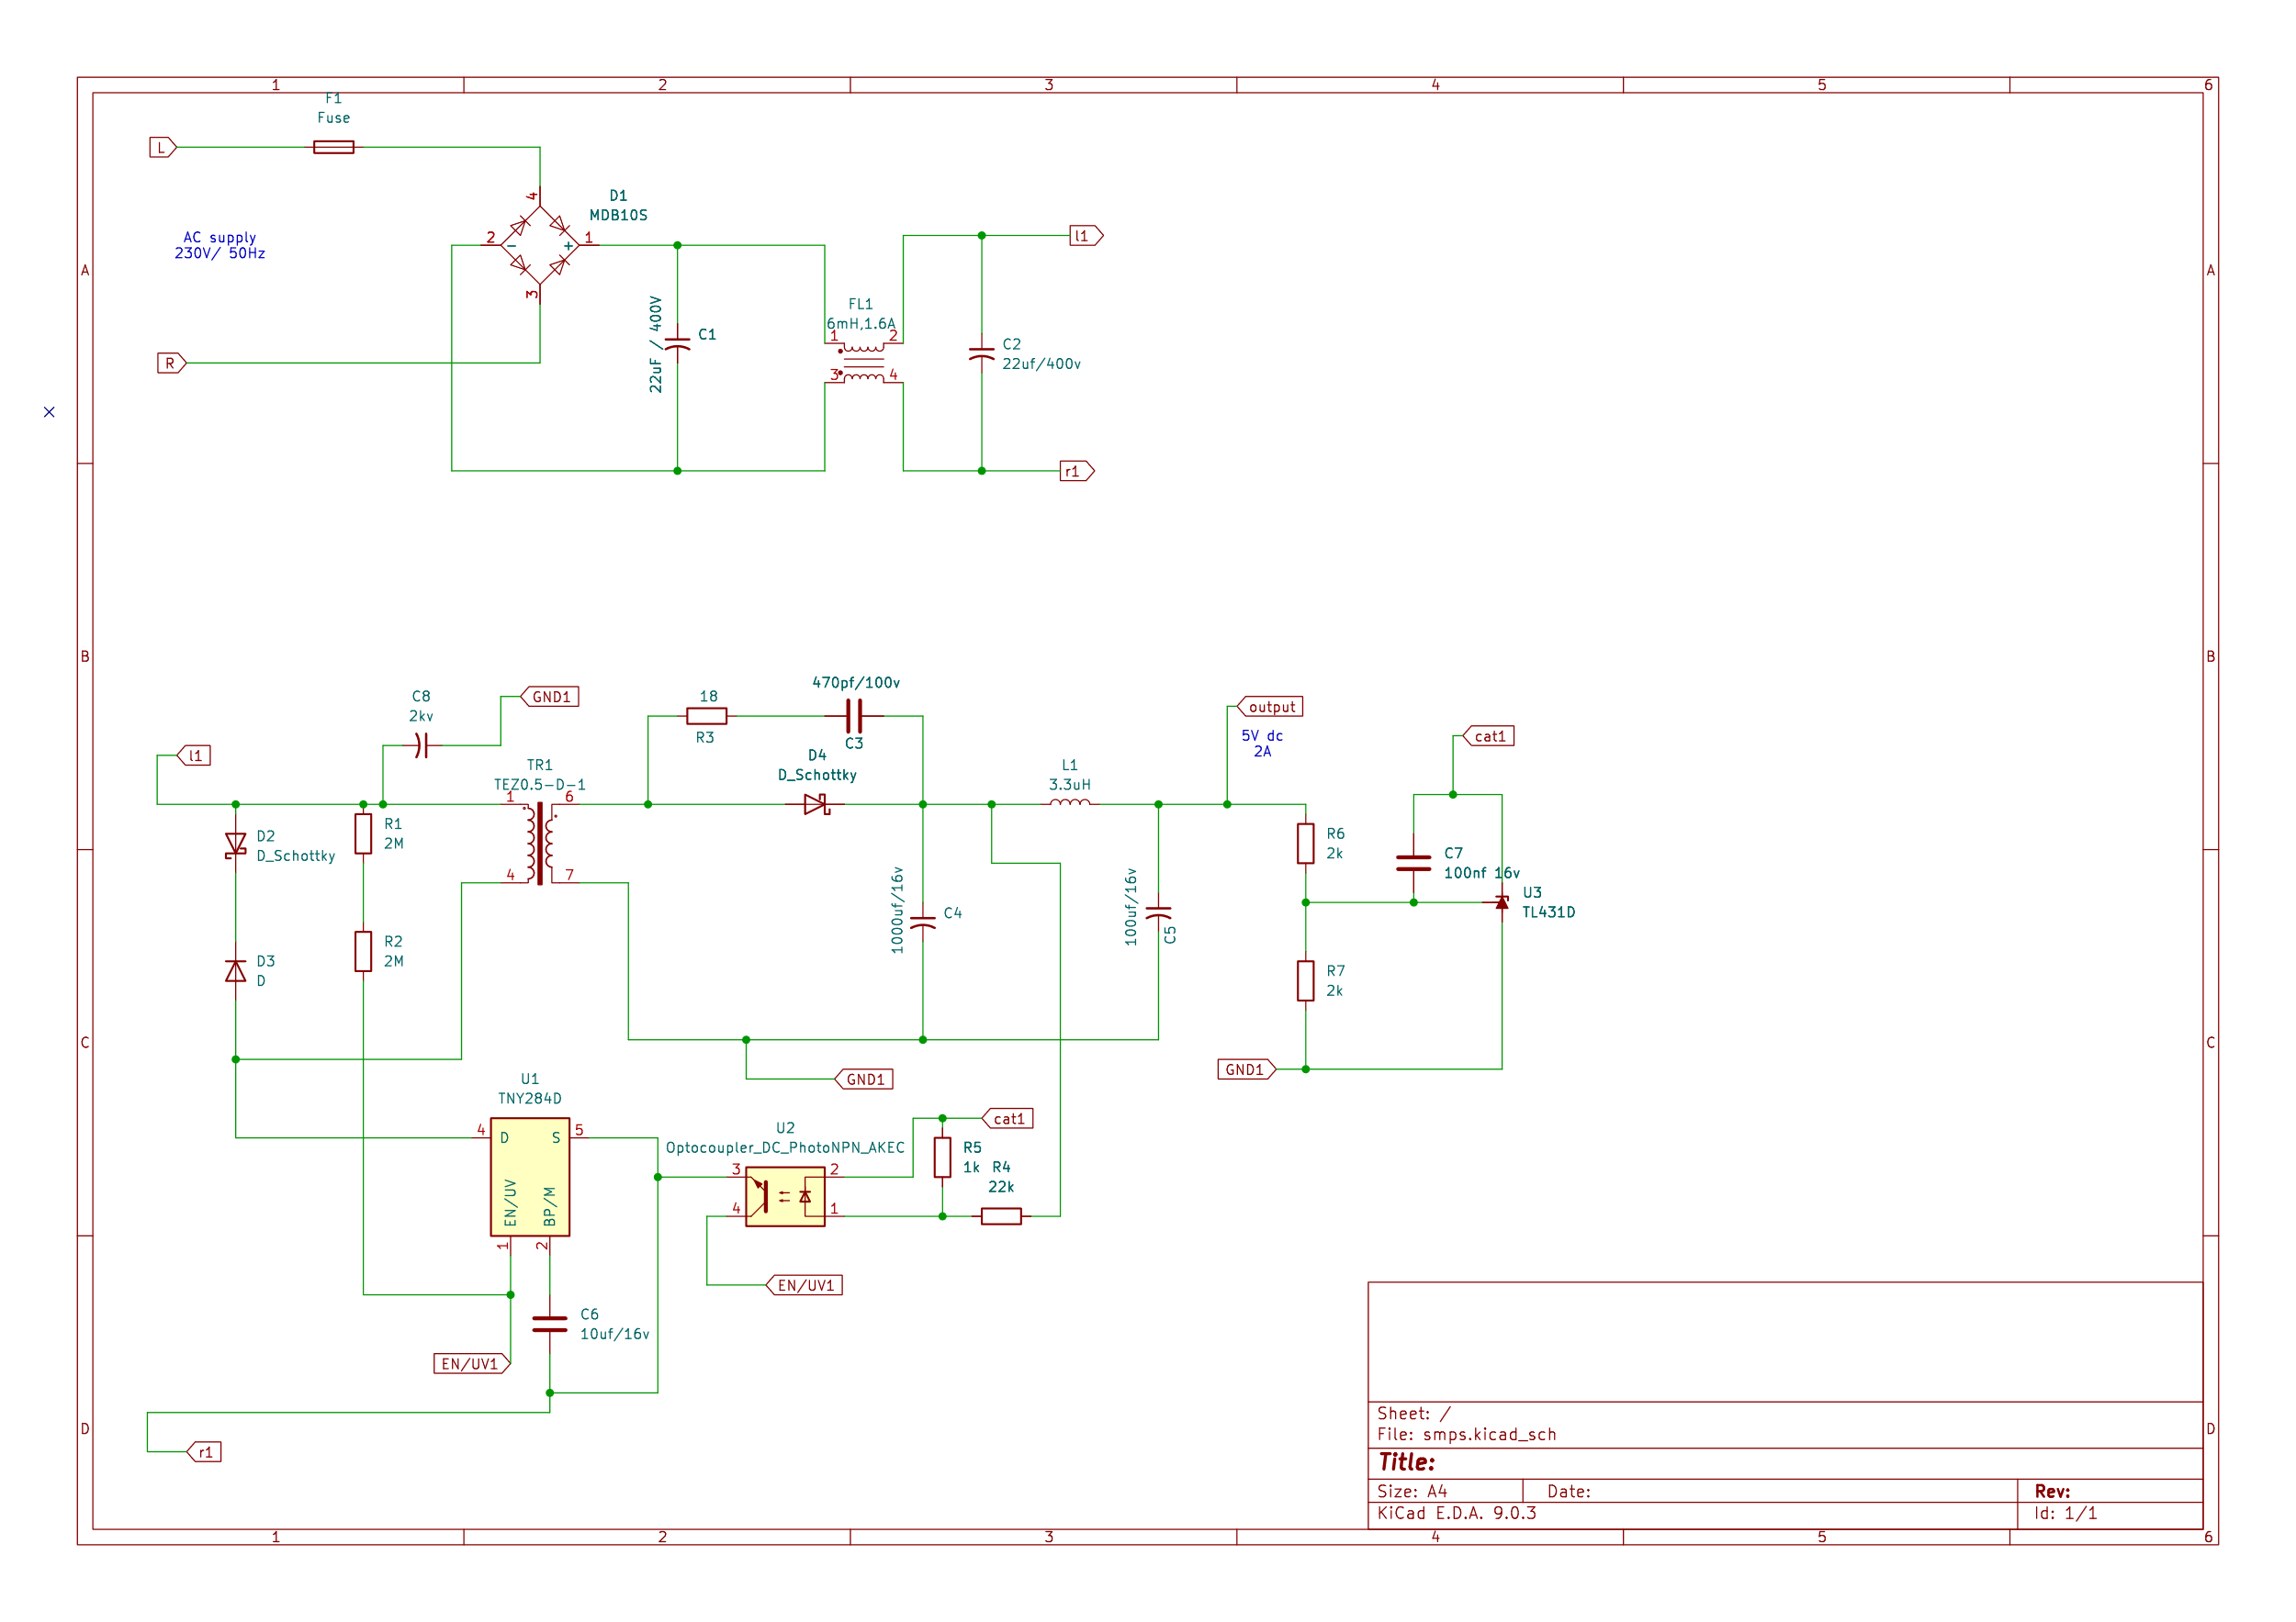

**Circuit explanation:**

The circuit takes dangerous 230 V AC, converts it into high-frequency isolated DC via a flyback SMPS, and uses optocoupler feedback to regulate it to a safe 5 V, 2 A output.

